**ACTIVITY 11**

**NAME : M.Varshini COURSE : Mobile Computing Reg No : 192421293 COURSE CODE: ITA0302**

11. Design a wireframe for a mobile application that incorporates security measures using

Figma.

**Aim: -**

Using Figma design a wireframe for a mobile application (Bank app UI) that incorporates

security measures.

**Procedure: -**

1. open Figma

2. Create a new file

3. Select the Frames

4. Design Visual Elements

5. Make it Interactive

6. Add icons on the Frame

7. Incorporate Multimedia

8. Storyboard Animation

9. Review and edit the Prototype

10. Save and Share

Design: -

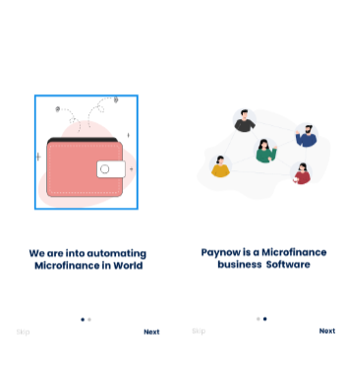

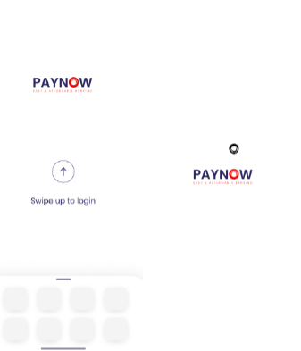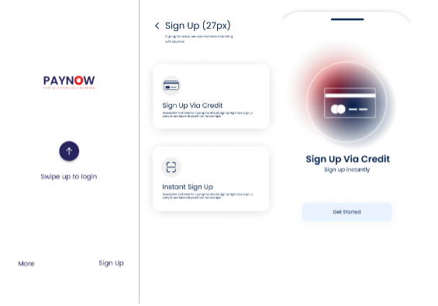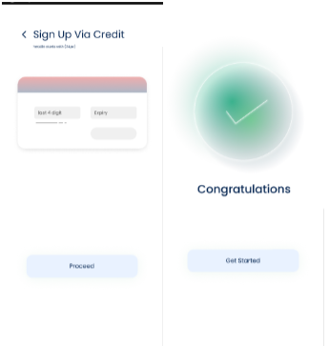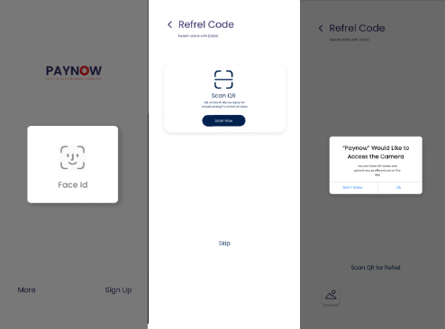

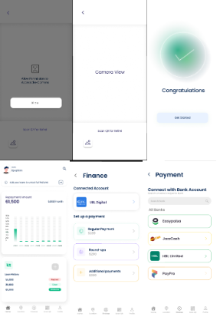 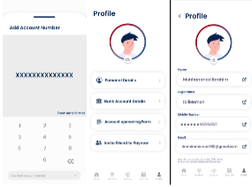 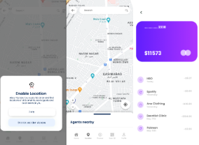 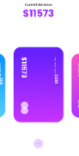

**Prototype: -**

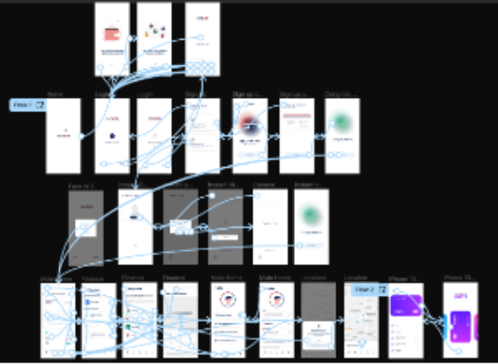

**Result: -**

A wireframe for a mobile application that incorporates security measures using Figma is created

and executed successfully